Customizing Back office

First go to the Command Prompt.

--> ant extgen

--> Template: ybackoffice (type ybackoffice after extgen finished)

--> Extension name: cuppytrailbackoffice (type cuppytrailbackoffice after ybackoffice finished)

--> Package: com. hybris. cuppytrailbackoffice(type com.hybris.cuppytrailbackoffice after cuppytrailbackoffice finished)

--> Create a sample widget: false (type false after com.hybris.cuppytrailbackoffice finished)

--> Create sample style sheets: false (type false after Create a sample widget finished)

Now, follow the instructions given and include the newly generated extension in your local extension.xml file.

In localextensions.xml file

<extension name="cuppytrailbackoffice" (extension name) />

Note: Rebuild your code base with the ant all command and import the cuppytrailbackoffice and back office projects into Eclipse (note that cuppytrailbackoffice requires back office).

<context component=*"explorer-tree"* merge-by=*"module"*>

<n:explorer-tree xmlns:n=*"http://www.hybris.com/cockpitng/config/explorertree"*>

<n:navigation-node id=*"Cuppytrail"*>

Name of the node (Appear on left side)

<n:type-node id=*" FamilyPromotion "* code=*"FamilyPromotion"* />

same as code code from Vodafonecore-items.xml(Table)

</n:navigation-node>

</n:explorer-tree>

</content>

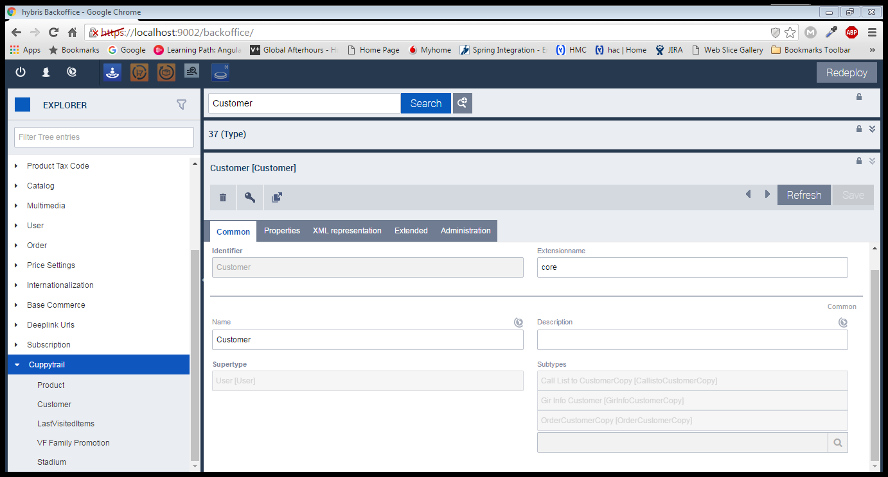

type-node

navigation-node

<context type=*"Product"* component=*"listview"*>

Code from Vodafonecore-items.xml (table)

<list:list-view xmlns:list=*"http://www.hybris.com/cockpitng/component/listView"*>

<list:column qualifier=*"code"* />

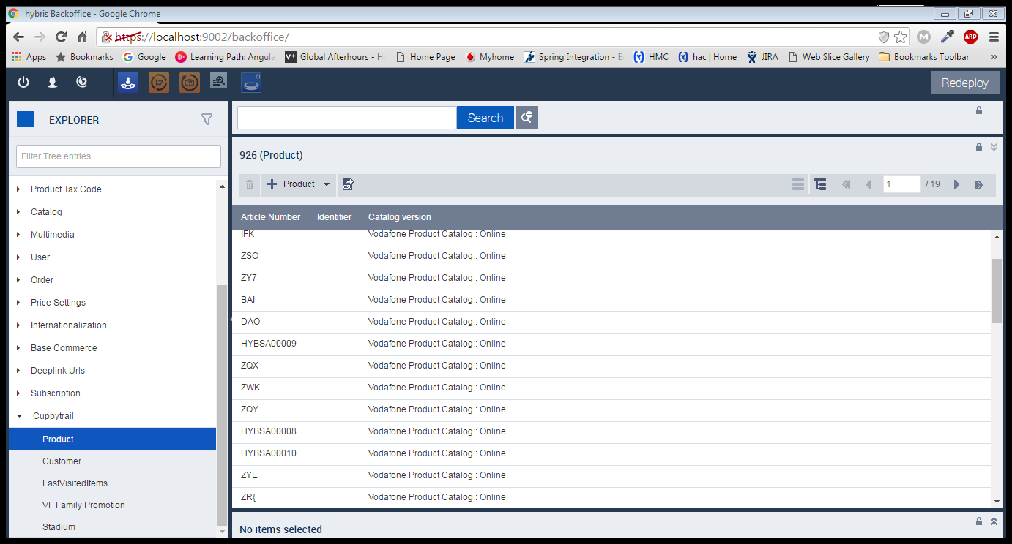It will create a column for product as shown in the above fig.

<list:column qualifier=*"name"* />

<list:column qualifier=*"catalog Version"* />

</list:list-view>

</context>

Creating Tabs in Back office

Code from Vodafonecore-items.xml (table)

<context component=*"editor-area"* type=*"Stadium"*>

<editorArea:editorArea xmlns:editorArea=*"http://www.hybris.com/cockpitng/component/editorArea"*>

<editorArea:tab name=*"essentials"*>

<editorArea:section name=*"essentials"*>

<editorArea:attribute qualifier=*"code"*/>

<editorArea:attribute qualifier=*"StadiumType"*/>

</editorArea:section>

<editorArea:section name=*"data"*>

<editorArea:attribute qualifier=*"capacity"*/>

</editorArea:section>

</editorArea:tab>

<editorArea:tab name=*"dates"*>

<editorArea:section name=*"dates"*>

<editorArea:attribute qualifier=*"creationtime"*/>

<editorArea:attribute qualifier=*"modifiedtime"*/>

</editorArea:section>

</editorArea:tab>

</editorArea:editorArea>

</context>

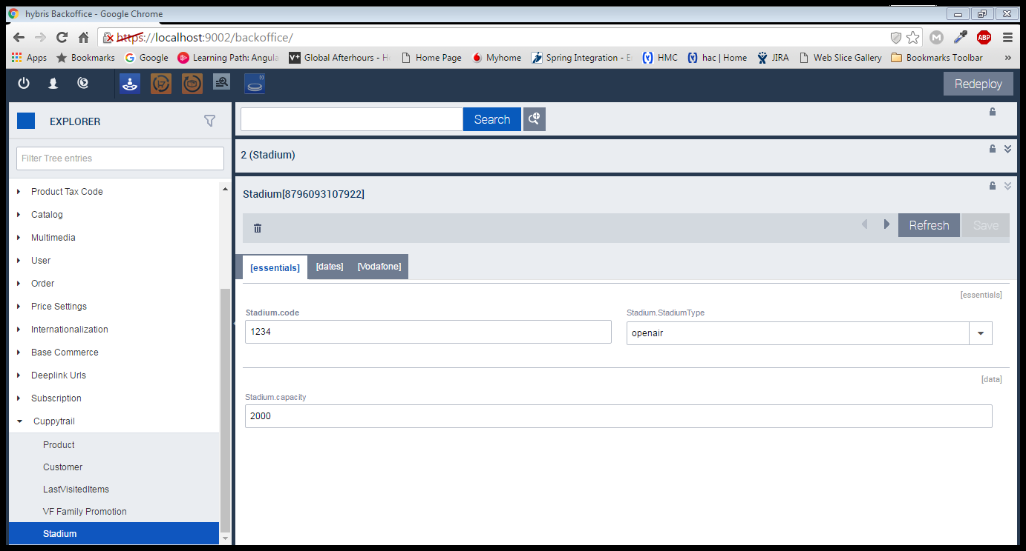

Tabs EditorArea:attribute qualifier EditorArea:Section

<context type=*"Customer"* component=*"create-wizard"*>

<wz:flow xmlns:wz=*"http://www.hybris.com/cockpitng/config/wizard-config"*

id=*"CustomerWizard"* title=*"Create New Product"*>

<wz:prepare id=*"custPrepare"*>

<wz:initialize property=*"newCust"* type=*"ctx.TYPE_CODE"* />

</wz:prepare>

<wz:step id=*"step1"* label=*"Step 1"* sublabel=*"Information"*>

<wz:content id=*"step1.content"*>

<wz:property-list root=*"newCust"*>

<wz:property qualifier=*"firstName"* type=*"java.lang.String"* />

<wz:property qualifier=*"middleName"* type=*"java.lang.String"* />

<wz:property qualifier=*"customerID"* type=*"java.lang.String"* />

</wz:property-list>

</wz:content>

<wz:navigation id=*"step1.navigation"*>

<wz:cancel />

<wz:next

visible=*"!#empty(newCust.firstName) and (newCust.middleName!=null) and (newCust.customerID!=null) "* />

<wz:done

visible=*"!#empty(newCust.firstName) and newCust.middleName!=null and newCust.customerID!=null "*>

<wz:save property=*"newCust"* />

</wz:done>

</wz:navigation>

</wz:step>

Wz:Cancel – Cancel button

Wz:next – next button

Wz:Done – Done button

<wz:save property=*"newCust"* />

It will save the given data to newCust

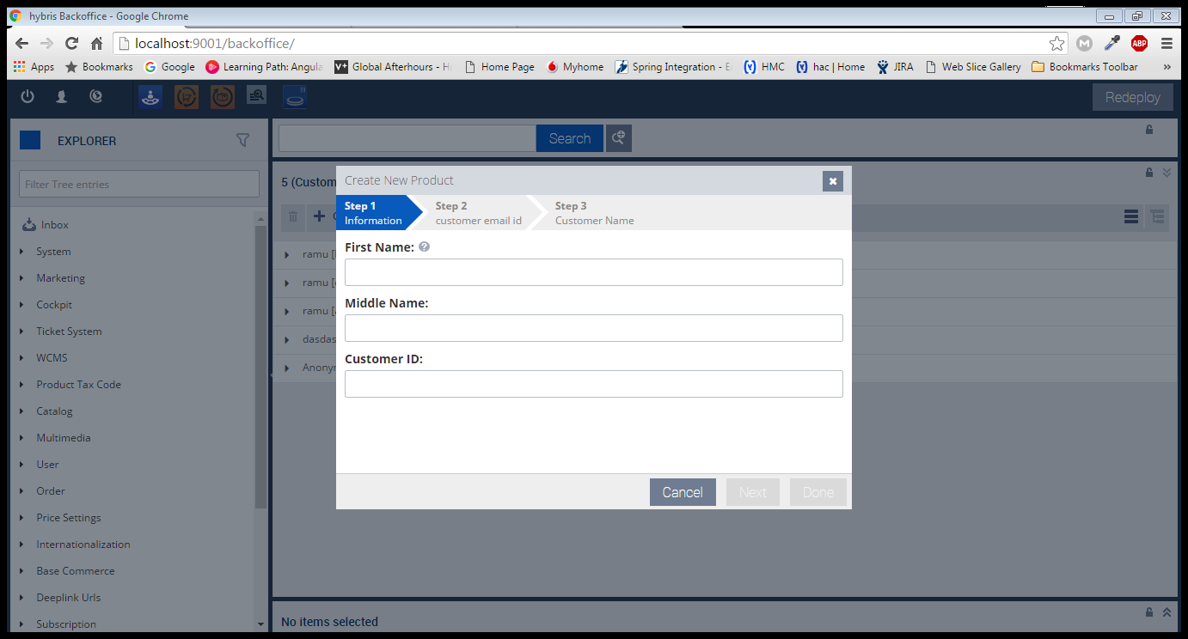

Wz:Property qualifier

Wizard's